1. If there is a Monthly Minimum, Usage AI will need to be turned on



* 1. What is the Monthly Minimum?
     1. The customer will always pay at least the monthly minimum — if their usage is lower, they’ll be invoiced for the full minimum after the month ends, and if their usage exceeds it, they’ll just pay the higher amount.
     2. We need to set up usage AI to automatically invoice the full minimum at month-end whenever usage falls below it.
  2. Do not process the monthly minimum as a separate BT. It will only be captured by the usage AI module
  3. Process all usage BTs

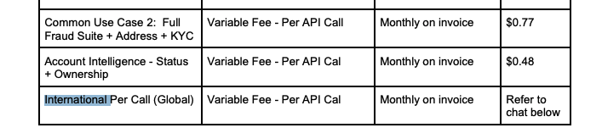

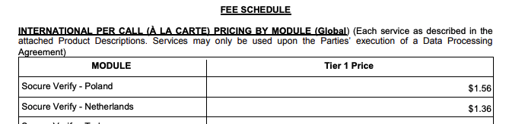

* 1. Click on **5. Usage AI** in garage
  2. Select **Has usage requirements** and **Has Minimum**

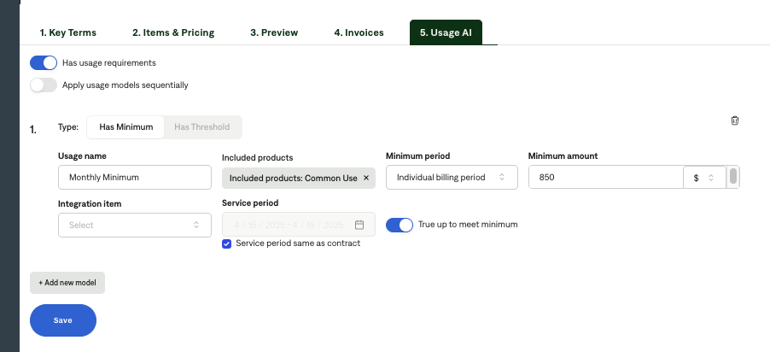

* 1. Usage name: Monthly Minimum
  2. Included products: select ALL usage products
     1. You will select these in a dropdown
  3. Select individual billing period for minimum period
     1. This will cause the monthly minimum to track each billing period for the usage BTs
     2. So if there is a monthly API call usage BT, the minimum amount will apply each month since the BT is set up to occur monthly
  4. Select “True Up to Meet Minimum” button